Bank details report using group by

Customer sales details Tablix report

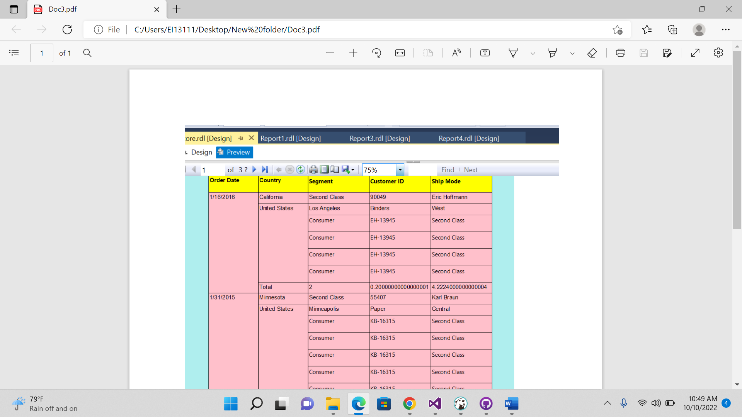

maximun number of atm onsite with respect to the bank and year using line chat

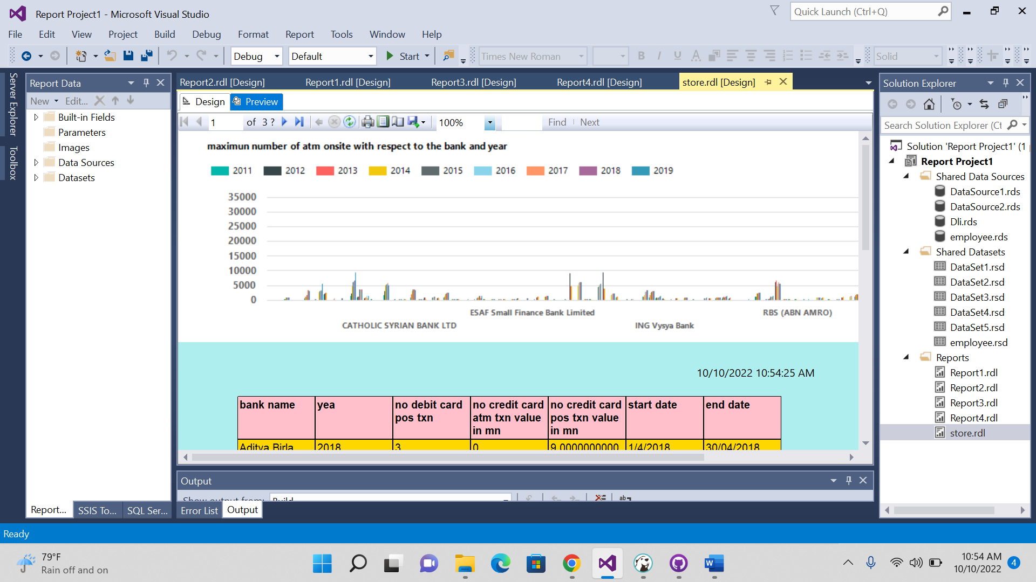

Drill down report

Employee salary details using chats

